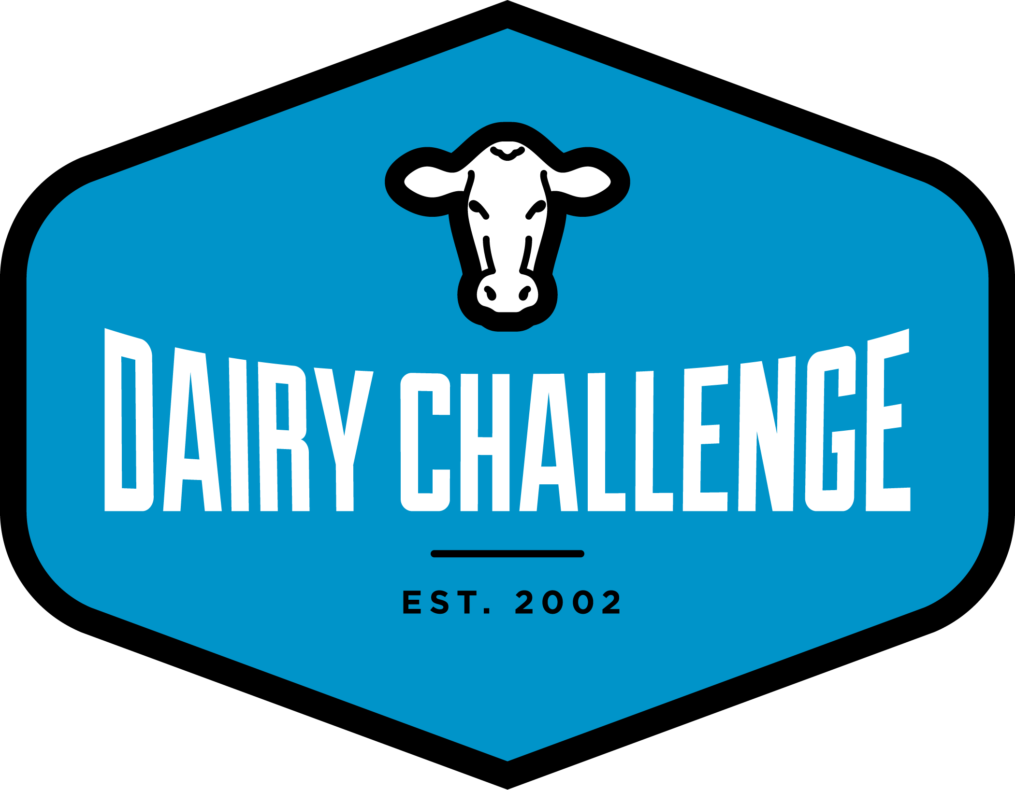 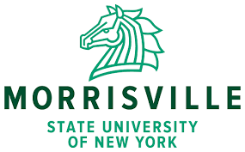

September 8, 2021

Dear Coach,

On behalf of the 2021 Northeast Intercollegiate Regional Dairy Challenge, we would like to invite you to the area between the Adirondacks and the Tug Hill Plateau, NY area. This year’s event will take place October 14-16, 2021. Please review the schedule so you and your students will be current with your expectations at this event. There will be three dairy farms utilized for this year’s contest. The Dairy Challenge will form aggregate teams (5 students/team) from all students entered in the competition. Teams will be assigned to analyze one of the three farms. Coaches will be allowed to visit all three farms, but will not be allowed to help their students prepare their presentation.

* Please bring your own computers with you. Programs you will be utilizing include Microsoft Office, Dairy Comp 305, PCDART, and Adobe Acrobat. (Apple computers do not work with Dairy Comp 305)
* To download the Academic version of Dairy Comp 305 to your own computer:  [DCTeach Info Sheet](https://www.dairychallenge.org/pdfs/student_resources/DC-TEACH-Info-Sheet-DairyChallenge.pdf) - Attention Academic Version Users, click to view and download ACADEMIC backup. If you need help, [click here](mailto:Craig@vas.com?subject=Dairy%20Challenge%20DCTeach%20help)
* PCDART Software Installation Information - To install PCDART software, contact Kas Ingawa, DRMS at (919) 889-9131
* Students will be using PowerPoint for their presentations.
* Plan to dress appropriately for farm visits in New York in mid-October (there is a high risk that the weather may be cold or cold and rainy).
* Business attire is expected for the PowerPoint presentations. Please explore the Dairy Challenge website for helpful hints regarding dresscode for our event
* Additional resources area available at: <https://www.dairychallenge.org/member-access/index.php> Password is “coach”.
* Student resources are available at: <https://www.dairychallenge.org/student-resources/>

The Dairy Challenge will be based at the 3 Willows Event Center, 3950 State Route 12, Lyons Falls, NY for the duration of the event. A block of rooms have been reserved for Wednesday, Thursday, and Friday nights. You will be responsible for the cost of the room on Wednesday night. You can pay for Wednesday night at Dairy Challenge Central with a check or a credit card. **Do** **not call the hotel to make your room reservations.** Room reservations for students and coaches will be handled by the Dairy Challenge. Rooms and meals will be provided for team members from Thursday breakfast through Saturday lunch at no cost to the student participant. Dairy Challenge will pay for the coach’s room if the coach if the coach is willing to share with a coach from another school (1 coach/school). Please indicate on the Coach Registration Form your roommate preference. If you prefer a single room, please indicate that and we will reserve the room for you, but you will be responsible for $79/night + tax and fees. Meals for 1 coach/school will be covered. Additional coaches from the same school will need to pay $150.

Check in for the program begins Thursday morning at 8:00 AM, our program for students begins at 10:00 AM. It is important to the success of students’ experience that your students arrive on time and please let Wanda know your anticipated arrival time.

Thursday afternoon we will head to three great dairies, Friday morning will see our teams sharpening their presentations with the first presentation to get started Friday afternoon and the last presentation happening prior to noon on Saturday when you will be free to leave after lunch.

Attached you will find registration forms for you and your students. We are limited in the number of students to 120 students, so register by September 24 to ensure your participation in this exciting event. Please review eligibility guidelines, contact Wanda, [Emerich@whminer.com](mailto:Emerich@whminer.com) if you have questions.

Registration Procedures:

Coaches, please forward the attached form (registration21) to any students you would like to have participate in the contest. You will need a copy of Adobe Acrobat to fill out the registration form. Adobe Acrobat Reader is available for free at this website: <http://www.adobe.com/products/acrobat/readstep2.html>

Coaches, please fill out the name and address portion of the registration form so we know that we have the correct contact information for you.

Students-

1. Fill out the attached form (registration21) and email the file to [emerich@whminer.com](mailto:emerich@whminer.com) . If your computer will not allow you to submit this information electronically(sometimes it doesn’t work with Apple products), please print the form, fill it out neatly (I need to be able to tell the difference between 0 & 1(numbers) and O & l (letters) in order to get some of your e-mail addresses correct!), then e mail it to the address below, or fill it out, take a picture of it and e-mail the picture to me at [Emerich@whminer.com](mailto:Emerich@whminer.com) . Call me if you have questions 518-593-1631. You may also send a file on FaceBook messenger to me.
2. Print pages 2 & 3, sign and return to your coach. Your coach will then mail them to Wanda Emerich, Dairy Outreach Coordinator, WH Miner Agricultural Research Institute, 1034 Miner Farm Road #90, Chazy, NY 12921 or FAX to 518-846-8445.

If you have any questions regarding registration for the Dairy Challenge, please contact Wanda Emerich at 518-846-7121 x117(office) or 518-593-1631(cell).

Sincerely,

**Molly Scoville**

**Host Committee Chair**

**Dr. Steve Mooney**

**Host School Chair**

# Coaches Registration Form

Northeast Regional Intercollegiate Dairy Challenge, October 14-17, 2021, Lyons Falls, NY

**ENTERED BY:**

Coach______________________________________________________

College/University____________________________________________

Address_____________________________________________________

City____________________________State______ZIP_______________

Phone__________________________FAX________________________

Cell____________________________

e-mail______________________________________________________

____I will pay for my own room ($79/night) and let Wanda make the reservation for me.

____I would like to share a room with____________________and trust that Wanda will make this reservation for me and Dairy Challenge will pay for this room.

We plan to arrive at approximately:__________ on Wednesday/Thursday(include date and approximate time)

Special Diet or Other Special Requirements:

**APPROVED BY:**

Department Chair/Dean_________________________________________

Address_____________________________________________________

City________________________State____ZIP_____________________

Phone_______________________FAX___________________________

e-mail______________________________________________________

# RULES & PROCEDURES

## **Steering Committee**

The steering committee is made up of representatives from universities with agricultural programs throughout the northeast and representatives from the dairy industry. The committee is responsible for preparation, presentation, application, and evaluation of the event.

## **Superintendent**

The superintendent shall have complete charge of the contest. The superintendent shall see that all rules and regulations governing the contest are duly carried out and that the contest is conducted with fairness and justice to all concerned. The superintendent shall decide all questions that may arise in connection with interpretation of the rules. The Northeast Regional Dairy Challenge Host School Chair for the 2021 contest is Dr. Steve Mooney, [mooneycs@morrisville.edu](mailto:mooneycs@morrisville.edu) , with Northeast Superintendent, Molly Scoville, [molly.scoville@merck.com](mailto:molly.scoville@merck.com)

**Teams & Entries**

Teams will be made up of five participants based on each team member’s knowledge and proficiency area, and grouped in aggregate fashion. (i.e. – A team may be made up of students from UVM, VTC, Cornell, Cobleskill and U Mass). Colleges are not limited to a certain number of students they can bring. However, the event is capped at 120 students and colleges will be placed on a first come, first serve basis. Due to the aggregate approach, colleges can still participate even if they do not bring five students.

# Travel, Food and Lodging Expenses

Lodging expenses at the Three Willows Event Center Lyons Falls, NY will be paid by the contest for students. Meals provided by the contest start with lunch on Thursday, followed by dinner on Thursday. Then breakfast, lunch and dinner on Friday, and breakfast and lunch on Saturday. Meals are provided by the contest through generous support of the dairy industry. A variety of snacks will also be available. If you plan to arrive on Wednesday night, please indicate this on your registration form and we will make that reservation for you. If there is more than one coach/school, the cost for that additional coach will be $150 to cover meal costs for the entire event.

# Eligibility of Contestants

Each participant must be an undergraduate student in an educational institution, international or domestic, that offers a full degree in agriculture. A contestant must be enrolled in a program of study to meet the requirements for a degree. They must have completed no less than one year of course work or equivalent. In accordance with the National bylaws, students who have participated in the North American Intercollegiate Dairy Challenge (national contest) are not eligible to participate in the Northeast Regional Dairy Challenge. Students who have participated in two previous regional Dairy Challenges are not eligible to participate in an additional regional Dairy Challenge. Please call 518-846-7121 x117 if you have any questions regarding eligibility of a contestant.

* All students must have completed at least one year of approved dairy science relevant course work and/or practical dairy work experience as determined by the coach of each student’s respective college.
* Stage 1
  + Each college is allocated at least 5 slots, but may bring more or less than 5 students if appropriate
  + 2-year college/programs will be entitled to send 50% of their eligible 2nd year students enrolled.
  + 4-year college/programs will be entitled to send 50% of their eligible 3rd or 4th year students enrolled.
* Stage 2 (if necessary to meet established enrollment goal for the challenge)
  + Through mutual agreement of participating college, all remaining slots will be filled.
  + Preference should be given to seniors who will not have a future opportunity to participate or first time students.
  + The goal will be to fill the remaining students with a balance from each college.
    - *\*\* Recognizing the diversity of the dairy programs of the participating colleges, and in the attempt to be as equitable as possible, student selection will be done in accordance in keeping with the “spirit of the Dairy Challenge.”*

# Aggregate Team Concept and Group Participation

The concept of aggregate teams is being used to eliminate competition between colleges, facilitate a powerful learning environment, and create a “real world” situation for students. It is very highly recommended that each student become extremely engaged in the concept of being part of a team!!!

# Judging System

A panel of five judges (selected by the steering committee) will hear all of the presentations and make the final rankings. The judging panel shall consist of members who have dairy expertise in the fields of dairy production, nutrition, reproduction, genetics, housing, finance, on-farm consulting and milking procedures.

The judging panel will use the Northeast Regional Dairy Challenge Scorecard to arrive at the final rankings. The judging panel will provide a team evaluation for each team immediately following their presentation.

# Dairy Challenge Scorecard is also attached to this e-mail

# Data and Materials

Each team will work independently with no aid from coaches. A variety of mentors will be available to assist students. The team of mentors will be from a variety of different sources and areas of expertise and will be available to their assigned farm Thursday lunch and throughout presentation development. Their purpose is in answering questions, but not in making decisions for the team. There will additionally be experts available in the Resource Room throughout the contest. Students may contact the Dairy Challenge Central ‘Resource Room’ during the contest for assistance. In the Resource Room there will be industry representatives from a variety or specialty within the dairy industry. Students are allowed to utilize the internet during presentation development. Calculators, measuring tapes, and clean notepads are the only equipment allowed to be taken onto the farm. No other equipment will be allowed. The contest has digital cameras available for each team to utilize. The data will be the real on-farm data. The data may consist of farm goals, financial statistics, cost details and estimates, ration formulations for all feeding groups, feed inventories, housing dimensions and characteristics, milking procedures and equipment specifications, reproduction data, ancestry identification if available, production records, and herd summaries, with a history of production characteristics for the last 2-3 years. The data will be provided on hard copy using standard industry formats and/or in selected computer formats.

# Honor System

Event staff has elected to let participants use the honor system. This simply means, “Follow the guidelines and rules presented to you by contest management.”

## **Structure of Visits**

The teams will be handled in groups, 8 teams per farm visit. Advisors (coaches) are allowed to visit the farms, but must not assist the teams in any way. Each farm visit will consist of 120 minutes, with each team deciding how to allocate their members to cover all areas of the farm. There will be mentors at the farm to monitor students and provide direction when needed. For bio-security purposes, all equipment must be disinfected prior to the visit. Each team will be allowed to question the farm manager and employees as time and availability permit. Teams will return to the Three Willows Event Center, Lyons Falls, NY to prepare for farm manager interviews and their presentations. The judge’s panel will have a separate interview with the manager to determine their official recommendations.

# Team Manager Interviews

On Thursday evening, each team will designate a representative(s) to engage in a group facilitated question and answer period with the farm manager for up to 30 minutes to get additional information about data already provided and their visit. There will be four groups/30 minute time period. A timekeeper will monitor this. Moderators or judges will be present during the session to exclude questions that call for a conclusion on the part of the manager.

# Presentations

Presentations will take place starting at 1:00 PM on Friday at the Three Willows Event Center, Lyons Falls, NY. The rest of the presentations will take place at the Three Willows Event Center, Lyons Falls, NY starting at 7:30 Saturday morning.

Each team will complete their presentations on Friday at 10:00 AM and will deliver their copies and all presentation materials to contest management. Teams will work in assigned individual hotel rooms to prepare their presentations. Presentation order will be scheduled and each team will be assigned to Friday afternoon or Saturday morning presentation sessions. One hour before their assigned presentation time, teams will be able to receive a printed copy of their PowerPoint presentation and will be directed to a Practice Room. Each team will be required to perform a presentation to a panel of five judges. The presentations should be designed as if the team was making a presentation to the farm owner or manager. It is not necessary to describe the farm to the person who owns the farm as an introduction. Begin discussing benchmarks or important outcomes of your evaluation as soon as possible. The presentation must recommend improvements to the operation of the dairy and its finances.

Each team will be allowed 20 minutes for their presentation and an additional 10 minutes for questions from the judge’s panel. 10 minutes will be allotted for judges to provide immediate feedback and evaluation to each team. Total presentation time is 40 minutes. Each team member must take part in the presentation. Presentations will be held in a classroom setting. Only individual team members coaches/advisors, members of the host farm, members of the judge’s panel, members of the participating team, sponsors, and event management are allowed in the room during each team’s presentation. Audience members will not be allowed to enter or leave the room until the entire presentation is complete. After each presentation, the judge’s panel will privately rate each team. After all presentations are given, a final rating will be given to each team. In addition, each team will be provided with the judge’s comments identifying areas of strength and opportunity immediately after their presentation**.**

# Bio-Security

* All contestants are required to wear plastic boots for each farm visit and clean clothing.
* Any individual who has been in contact with infected farms or animals should have no contact with wild or domestic animals at least 10 days before arriving at the contest and should be wearing protective clothing different from that worn on the infected farm.
* All equipment that teams bring to the contest must be disinfected. A thorough disinfectant wash with a substance that kills major disease-causing agents is acceptable.

# Benefits and Awards

Teams will be ranked in each host farm division. First and second place teams will be announced, other teams will be recognized in random order.

**PLEASE RETURN by September 14**

* Liability Waiver included in pdf file (coach send printed copies from your students)
* Authorization for Personal Information Release included in pdf file (coach send printed copies from your students)
* Skills Assessment & student registration form (e-mail data to [Emerich@whminer.com](mailto:Emerich@whminer.com) )
* Coaches Registration Form (page 3 of this note)
* A note with any special request (special diet, etc.) that we need to know.

SEND TO:

Wanda Emerich

W.H. Miner Agricultural Research Institute

PO Box 90

Chazy, NY 12921

Please call with any questions!

518-846-7121 x117

518-593-1631 (cell)

**You will have the opportunity to purchase T-shirts at a website that I will send to you upon registration. They will be available for pick up at the event in October.**

**Your students are required to submit a resume with their registration form. There will be several potential employers for internships or jobs at the event.**