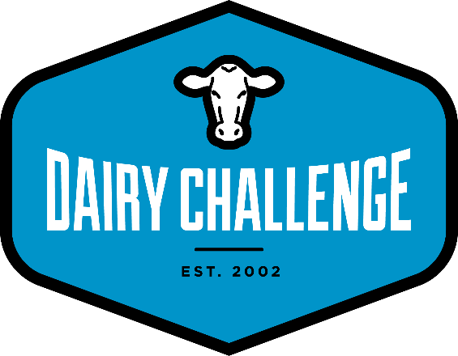
August 18, 2020

RE: NAIDC 15th Annual Southern Regional Dairy Challenge VIRTUAL
September 22 – October 22, 2020

Dear Dairy Challenge Coach:

On behalf of the Southern Regional Committee of the North American Intercollegiate Dairy Challenge, it is our pleasure to invite your school to participate in the 15th Annual Southern Regional Dairy Challenge. This year’s event will be held virtually and hosted by University of Florida.

The Southern committee has redesigned the program to maximize student learning, involve sponsors, take advantage of online opportunities, minimize “zoom fatigue”, and support you, our coaches, in your teaching efforts.

The program will take place completely online from the Dairy Challenge web site. Recognizing that in many cases student contact time has been compressed, rather than the traditional contest schedule conducted in 3 consecutive days, the 2020 Southern Regional will begin with instructions and data distribution on Tuesday, September 22 and ending with the uploading of pre-recorded team presentations and judge Q&A the week of October 23. Weekly educational programming and team mentor meetings will be offered in between.

Teams will be by school rather than aggregate. As the coach, you are responsible for assembling and coordinating the team from your school. You may form a team with another school if necessary.

- Registration is online. This is the only method of registration. Registration fees can be paid using a credit card at the time of registration, or there is an option to pay with a check. Team registration closes Tuesday, September 8.

- Coaches do not have to collect and submit student forms. Students will be responsible for completing a single form online - a Student Information form. Once you have received confirmation from us, on or about September 9, students will have until Tuesday, September 15 to complete this form. This form will be available on the Dairy Challenge web site at http://www.dairychallenge.org/so_event.php

- Students must also submit a resume to complete their registration. Student information forms must be submitted, and resumes must be uploaded by the September 15 deadline. Students who miss the deadline without prior permission will be canceled from the event.

- Students will be allowed to use the internet during the Southern Regional contest.

- The contest will be using one farm with 3-4 panels of judges.

Participation
- This event is open to all schools in the Southern region and adjacent states.

- Completed entries will receive priority by registration date/time if contest size limits are reached.

- Schools may register one team with up to 6 participants. Please review Contest Rules, Eligibility of Contestants as you select participating students. Additional teams from a school will be considered if the contest limits are not met. If you do not have enough students to form a team, you are welcomed to combine with another school to form a team. We suggest teams of at least 3 and no more than 6 students.

- To ensure the contest flows smoothly, no changes may be made to students participating after September 15, 2020. Please note this date and plan accordingly.

Registration
Registration forms and entry fees are due by Tuesday, September 8, 2020.
- Online Registration: https://2020southerndairychallenge.eventbrite.com
  - Be prepared with your students’ email addresses when you begin registration
  - Upon completion of the team registration, the system will send you a confirmation and an email to each of the registered students with a link to the student information form and resume upload instructions.

- Student Information Form should be completed by each student after team registration is confirmed. The form is due September 15, 2020. The link will be posted on the southern page at: http://www.dairychallenge.org/so_event.php

- Entry Fee: $25 per student
  - If paying with a check, make checks payable to: North American Intercollegiate Dairy Challenge or NAIDC
  - Students will receive a free shirt with their registration. They should request their shirt size on the Student Information Form. Coaches may order a shirt when registering. All shirt orders from a university will be shipped to coaches for distribution.

Social Media Corps
In addition to contest participants, Dairy Challenge is looking for students who would be interested in serving on the Southern Social Media Corps team. Please visit with students in your club and your ag communications department about this opportunity. An updated application will be posted to the Southern page in the coming days. In the meantime, please contact Maegan Hollis Maegan.Hollis@mtsu.edu if you have students interested in applying for this role. More details will be coming soon!

Communications will follow once registration closes with additional information, and in mid-September with last minute details. We look forward to your participation in this exciting and innovative contest.

Sincerely,

Kas Ingawa
Southern Regional Dairy Challenge
Steering Committee Chair

