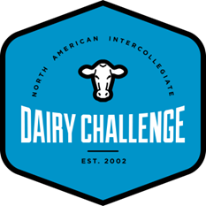
2020 North East Dairy Challenge Sponsorship Opportunities
Platinum Sponsor ($5,000)
- First opportunity for educational training prior to the event
  - 1 hour live and recorded training in the week before virtual event (not an advertisement)
- Sponsor link to advertisement of career opportunities (3 minute commercial)
- Opportunity to fill student box for event
- Access to student resumes participating in event
- Invitation to view the participant presentations
- Student contact information
- Recognition during virtual event
Gold Sponsor ($2,500)
- Second opportunity for educational training prior to the event
  - 1 hour live and recorded training in the week before virtual event (not an advertisement)
- Sponsor link to advertisement of career opportunities (3 minute commercial)
- Opportunity to fill student box for event
- Access to student resumes participating in event
- Invitation to view the participant presentations
- Student contact information
- Recognition during virtual event
Silver Sponsor ($1,000)
- Sponsor link to advertisement of career opportunities (3 minute commercial)
- Opportunity to fill student box for event
- Access to student resumes participating in event
- Invitation to view the participant presentations
- Student contact information
- Recognition during virtual event

Bronze Sponsor ($500)
- Opportunity to fill student box for event
- Invitation to view the participant presentations
- Student contact information
- Recognition during virtual event

Friends of Northeast Dairy Challenge (any amount up to $500)
- Invitation to view the participant presentations
- Student contact information
- Recognition during virtual event

