Alfred State Hosts 17th Annual Northeast Dairy Challenge

What: Northeast Regional Dairy Challenge

When: October 17-19th, 2019

Where: Most activities take place at the RIT Conference Center in Henrietta, NY, near Rochester. Dairy farms that students are visiting are in the region.

Around 100 students from all over the Northeast attended the 2019 Northeast Regional Dairy Challenge. Over the three-day event, students participated in hands-on opportunities that helped them prepare for careers in the dairy industry.

The Northeast Regional Dairy Challenge lets students be part of an educational experience while creating a real-world dairy evaluation. On arrival, students are put into mixed-university teams that they are to work with for the remainder of the competition. The Dairy Challenge strives to incorporate a higher learning atmosphere with practical application to help prepare students for a variety of careers in the dairy industry

When they arrived on Thursday, October 17th, they were bused to their assigned dairy farm that they were expected to evaluate. The goal of the teams is to determine aspects of the farm that can be improved upon and create a presentation for a panel of judges and the farm owners. Students were given time to work and practice on their presentations at the RIT Conference center. When they were not working of presentations they had the opportunity to attend activities such as SkyZone, the career fair, and listen to various different speakers.

About Dairy Challenge:

NAIDC is an innovative event for students in dairy programs at North American post-secondary institutions. Its mission is to develop tomorrow’s dairy leaders and enhance the progress of the dairy industry by providing education, communication and networking among students, producers, and agribusiness and university personnel. Over its 15-year national history, Dairy Challenge has helped prepare more than 5,000 students for careers as farm owners and managers, consultants, researchers, veterinarians or other dairy professionals.

Winners of the 2019 Northeast Regional Dairy Challenge:
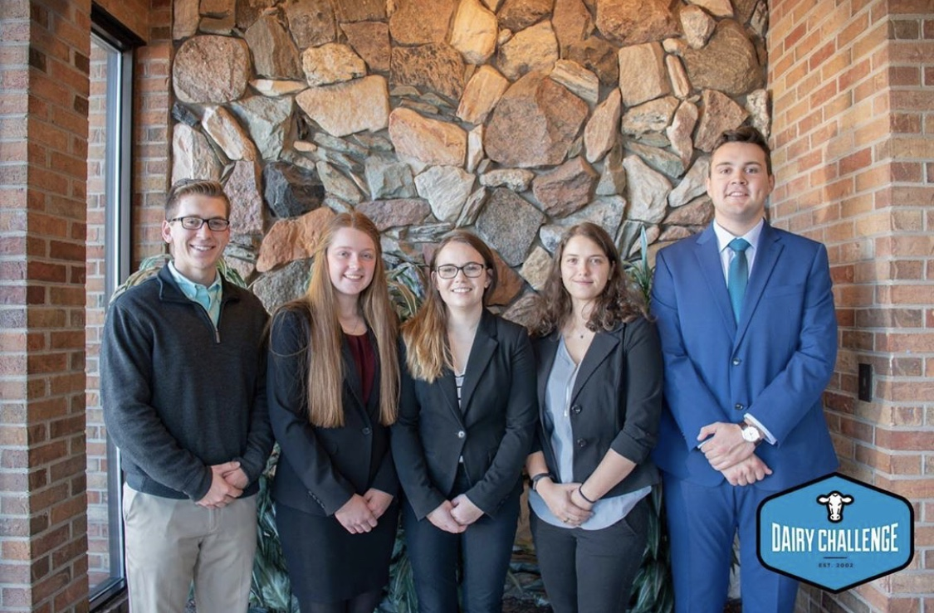

First Place Farm 1 Team 6: Northeast Dairy Producers Association L-R: Owen Greene, Aislynn Farr, Meghan Coldwell, Shoshana Brody, and Bruno Franco
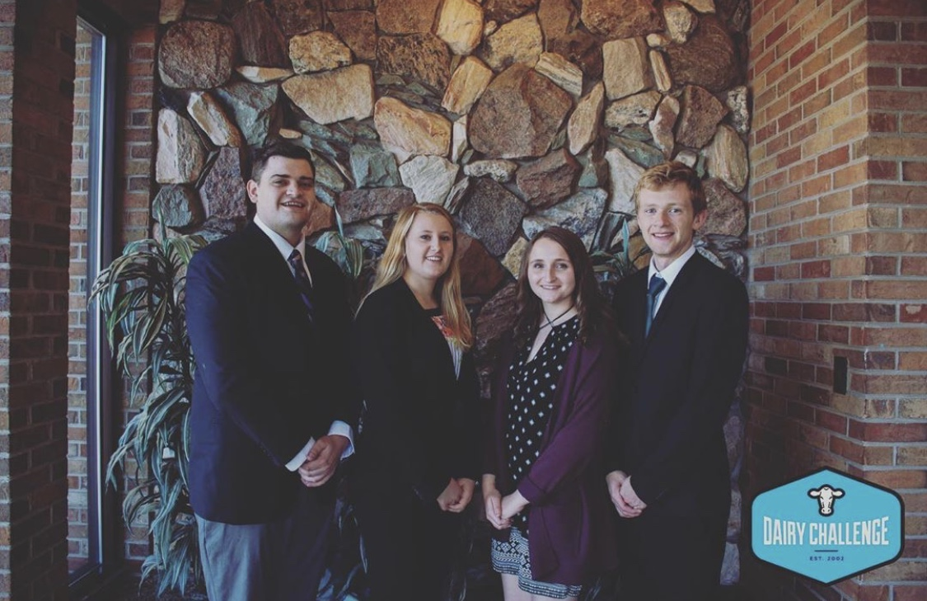

First Place Farm 2 Team 15: Diamond V L-R: Matthew Currie, Emily Ooms, Cara Ando, and Devin Kuhn

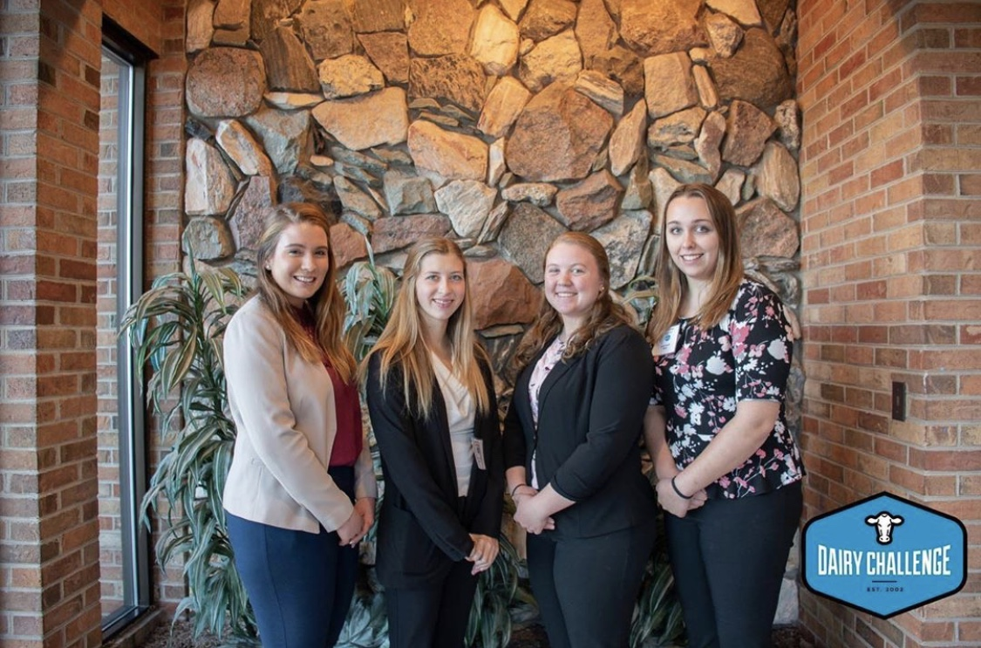

First Place Farm 3 Team 21: Adisseo L-R: Rebecca Dent, Morgan Cady, Courtney Charlesworth, and Julia Cummings

