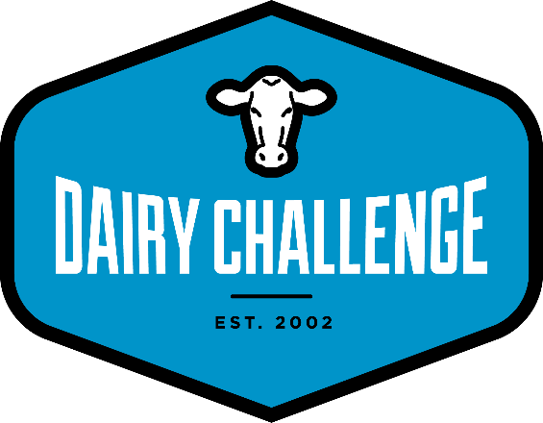
Computer Requirements for
2020 Midwest Regional Dairy Challenge

All schools are responsible for bringing computers to the competition. Two computers per team will be required for this event; contest data will be distributed on these computers. As such, we are recommending that each school bring at least TWO laptops computer (more if possible) with the following minimum requirements; these requirements are minimums – typically, bigger is better. While one of the computers will be loaded with the herd data in DairyComp 305 and PCDART programs, the other will be used to view contest materials and prepare presentations. In the event of a failure, loaner systems may or may not be available. We strongly encourage you to bring university computers rather than a coach’s or student’s personal computer for privacy reasons. Note, in addition to school computers, students are encouraged to bring their own computers for accessing the internet and use during preparation time.

Also, schools who have access to LCD Projectors are encouraged to bring one. The contest will need at least 4 total.

Hardware Minimums
Reliable, working, and in-good-condition PC laptop – absolutely no Macs without installed/configured Parallel (or similar) Software.
Operating system –Windows 7, 8 or 10 (fully patched with current updates).
Administrator logon and password – this is a MUST HAVE.
Processor – 1.5Mhz P4 Celeron processor or better.
RAM – 2 Gb or more.
Hard drive – minimum of 10 GB of free space after all software is loaded.
Video – 800x600 minimum resolution.
USB ports – 1 required, 2 or more better (version 2.0 preferred).

Software Minimums (to be loaded and tested prior to contest)
You are responsible for:
Microsoft Office 2007, 2010 or 2013 – regardless of version, all updates should be applied.
Anti-Virus software with current, up-to-date virus definitions.
Adobe 9 or higher.

Security and Password Protection:
If bringing university computers that have an Administrator logon and password, this login data must be provided to the IT staff at registration. This should be attached to the PC, and should be verified PRIOR to arrival at the contest. Also, please do not bring PC’s that reset and clear data once turned off.

The contest is responsible for:
– All Herd Data
– All Contest Data
– PCDART
– DairyComp 305

Both PCDART and DairyComp 305 (dairy herd management programs with the herd data) will be installed for you at the contest site.

Additional material
- Digital camera – schools are asked to bring a camera and responsible for having all memory cards, cables and hardware/software drivers for proper operation. Test before you travel. Use of cell phones, IPad’s, or other similar cameras is prohibited.
- Calculator, measuring tape, watch/stopwatch, pens and clean notepads.
- NRC Nutrient Requirements of Dairy Cattle can be freely downloaded from: https://www.nap.edu/catalog/dairymodel/
- Students are also encouraged to bring a jump/thumb drive to move information between computers.

Failure to meet the stated requirements above will, at a minimum, be a major hindrance on individual team performance and may at worst render the team non-competitive.

