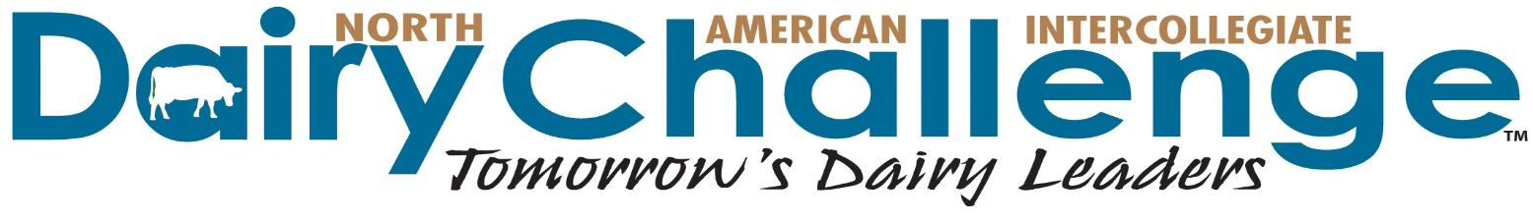

Dear Colleague:

Since 2002 Dairy Challenge has partnered with industry, producers and universities to build a workforce that is well prepared to face the challenges of the dairy industry. We are inviting you to sponsor the North American Intercollegiate Dairy Challenge to help top collegiate dairy students to develop countless skills – dairy management, teamwork, communication and problem-solving.

During a Dairy Challenge event, students work as a team to:
1) Evaluate a modern dairy through farm visit, record analysis and interviews with owner or manager.
2) Identify strengths and opportunities for the dairy.
3) Present recommendations to a panel of judges and sponsors.
4) Meet with key sponsors about career opportunities and new technologies.
Regional and Academy participants follow a similar format with one key exception: their "team" includes sponsors who share expertise and work directly with students to analyze and develop recommendations.

Your support of Dairy Challenge will enhance the abilities of young professionals entering the dairy industry. As a sponsor, you gain hands-on time with hundreds of students from 2- and 4-year colleges across the US and Canada who aim to be dairy industry professionals, producers and veterinarians. Evaluate their abilities first-hand. Identify top recruits and potential customers. Demonstrate your company’s latest innovations. Be a part of our program. Complete sponsor benefits are listed on the accompanying form and more program details are at www.dairychallenge.org.

The NAIDC has 100+ sponsoring companies and producers, more than half of which are Platinum Sponsors. As you evaluate your contributions for this coming year, please include Dairy Challenge in your plans. For maximum publicity, donate online at http://www.dairychallenge.org/sponsor_donation.php or return the enclosed commitment form at your earliest convenience, or by February 1.

Sincerely,

Chad Wright, DVM Dave Whitlock, Select Sire Power-Select Sires
Board Chair Finance Committee Chair
PH: (661) 477-7278 EM: chadwrightdvm@gmail.com PH: (540) 392-5693 EM: dwhitlock@selectsirepower.com

NAIDC Sponsor Commitment Form
Go to www.dairychallenge.org for complete information about Dairy Challenge
To pay by credit card, complete online using Donate Now link at http://www.dairychallenge.org/sponsor_donation.php
One-Star Platinum Sponsor - $10,000 +*
- Industry Technology Seminar at Dairy Challenge Academy
plus all other Platinum perks below
* Exclusive opportunities available to sponsors at $10,000 +

Platinum Sponsor - $5,000 +*
- Free unlimited job/internship postings on NAIDC's web site
- First opportunity to provide contest officials and Academy Advisors
- Sponsor recognition in national advertising
- Sponsor link from NAIDC web page
- Primary booth space for Innovation Fair at contests
- Participation in student recruitment mixers
- Recognition at national and regional contests
- Student contact information
- Invitation to view the participant presentations

Gold Sponsor - $2,500
- Two free job/internship postings on NAIDC's web site
- Booth space for Innovation Fair at contests
- Participation in student recruitment mixers
- Recognition at national and regional contests
- Student contact information
- Invitation to view the participant presentations

Silver Sponsor - $1,000
- One free job/internship posting on NAIDC's web site
- Recognition at national and regional contests
- Student contact information
- Invitation to view the participant presentations

Bronze Sponsor - $500
- Recognized at event sponsored
- Recognition at event awards program
- Invitation to view participant presentations

Yes, we will support NAIDC by providing the following contribution:

______ $10,000+ Platinum Sponsor*
______ $5000+ Platinum Sponsor
______ $2500 Gold Sponsorship
______ $1000 Silver Sponsorship
______ $ 500 Bronze Sponsorship

As a sponsor, your support will be used for each NAIDC event you designate below:
Use our funds as designated below:
$_________Northeast Regional
$_________Southern Regional
$_________Midwest Regional
$_________Western Regional
$_________ National Contest/Dairy Challenge Academy

_____ Yes, we would like to receive information about other ways to support NAIDC.

Company Name to Be Listed on All Sponsor Recognition:

_____________________________________________________________________

Send Invoice To:
Or, prefer to receive an invoice in: ____ December ____ January

Name ____________________________________________________________________________Title_____________________________________________

Address ___________________________________________________________________________________________________________________________
City _____________________________________________________________________________State________ Zip Code _____________________________

Telephone______________________________________________ Email ______________________________________________________________________

Send Thank You To:

Name ____________________________________________________________________________Title_____________________________________________

Address ___________________________________________________________________________________________________________________________
City _____________________________________________________________________________State________ Zip Code _____________________________

Telephone_____________________________________________ Email ______________________________________________________________________

Submitted By:__________________________________________________ Date:_________________________________

Please return form by February 1 to: NAIDC, 3310 Latham Drive, Madison, WI 53713
PH: 608-224-0400 FX: 608-224-0300 EM: naidc@wdexpo.com

For credit card payments, complete form online using Donate Now link at http://www.dairychallenge.org/sponsor_donation.php

