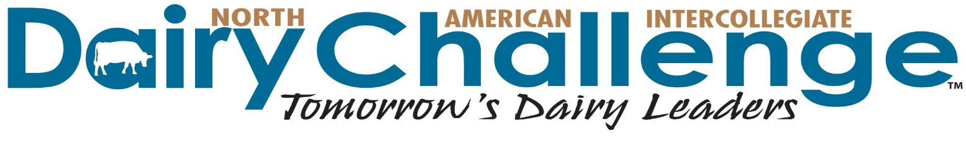
Dear Colleague:
As you consider plans for the current tax year, we are inviting you to consider a contribution to the North American Intercollegiate Dairy Challenge. This is a unique opportunity for you to partner with industry, universities and fellow producers to build a workforce that is well prepared to face the challenges of the dairy industry. As you may be aware the NAIDC is a contest that invites top collegiate students in dairy programs from North America to compete in a management analysis and recommendation program.

During a Dairy Challenge event, students work in teams to evaluate a modern dairy through farm visit, record analysis and interviews with owner or manager; identify strengths and opportunities for the dairy; present recommendations to a panel of judges consisting of producers and sponsors; and meet with key sponsors about career opportunities and new technologies.

There are a variety of producer sponsor levels for this event ranging from $100 to $1000. As a sponsor you will be recognized during our events, can serve as a judge or volunteer, and will receive student bio and contact information.

Your support of Dairy Challenge will enhance the abilities of young professionals entering the dairy industry. As a sponsor, you gain hands-on time with hundreds of students from 2- and 4-year colleges across the US and Canada who aim to be dairy industry professionals, producers and veterinarians. Evaluate their abilities first-hand. Recruit future members of your operation from a select group of dairy enthusiasts who want to be a part of our exciting industry. Be a part of both our regional and national contests. Complete sponsor benefits are listed on the accompanying form and more program details are at www.dairychallenge.org.

Benefits of Producer Sponsorship
- Free unlimited job postings on NAIDC's web site - Opportunity to provide contest officials and Academy Advisors
- Participation in student recruitment mixers - Recognition at national and regional contests
- Student contact information - Invitation to view the participant presentations

The NAIDC has 100+ sponsoring companies and producers. As you evaluate your contributions for this coming year, please include Dairy Challenge in your plans. We would be pleased and honored to list your farm as a sponsor of this innovative event. To become a sponsor we ask you to complete the form below. You can also pay by credit card online using our Donate Now link at http://www.dairychallenge.org/sponsor_donation.php

Sincerely,

Chad Wright, DVM Dave Whitlock, Select Sire Power-Select Sires
Board Chair Finance Committee Chair
PH: (661) 477-7278 EM: chadwrightdvm@gmail.com PH: (540) 392-5693 EM: dwhitlock@selectsirepower.com

NAIDC Sponsor Commitment Form
Go to www.dairychallenge.org for complete information about Dairy Challenge
To pay by credit card, complete online using Donate Now link at http://www.dairychallenge.org/sponsor_donation.php
Benefits of Producer Sponsorship
- Free unlimited job/internship postings on NAIDC's web site
- Opportunity to provide contest officials and Academy Advisors
- Participation in student recruitment mixers
- Recognition at national and regional contests
- Student contact information
- Invitation to view the participant presentations

Yes, we will support NAIDC by providing the following contribution:

______ $1000 Diamond Sponsorship
______ $ 500 Emerald Sponsorship
______ Other $_________ Friend of Dairy Challenge Sponsorship

As a sponsor your support will be used for each NAIDC event you designate below:

Use our funds as designated below:
$_________Northeast Region
$_________Southern Region
$_________Midwest Region
$_________Western Region
$_________ National Contest/Dairy Challenge Academy

_____ Yes, we would like to receive information about other ways to support NAIDC.

Name to Be Listed on All Sponsor Recognition:

____________________________________________________________________

Send Invoice To: Or, prefer to receive an invoice in: ____ December ____ January

Name ____________________________________________________________________________Title_____________________________________________

Address ___________________________________________________________________________________________________________________________
City _____________________________________________________________________________State________ Zip Code _____________________________

Telephone______________________________________________ Email ______________________________________________________________________

Send Thank You To:

Name ____________________________________________________________________________Title_____________________________________________

Address ___________________________________________________________________________________________________________________________
City _____________________________________________________________________________State________ Zip Code _____________________________

Telephone______________________________________________ Email ______________________________________________________________________

Submitted By: ____________________________________________________ Date:_________________________________

Please return form by February 1 to: NAIDC, 3310 Latham Drive, Madison, WI 53713
PH: 608-224-0400 FX: 608-224-0300 EM: naidc@wdexpo.com

For credit card payments, complete form online using Donate Now link at http://www.dairychallenge.org/sponsor_donation.php

