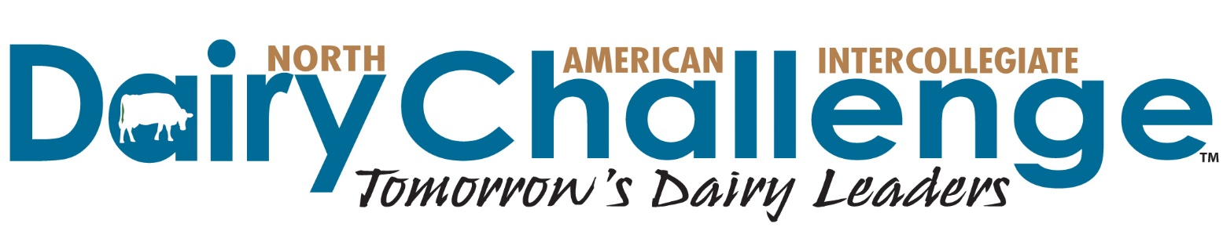
2017-2018 NAIDC In-Kind Sponsor Commitment Form
National Contest/Dairy Challenge Academy
April 12-14, 2018 in Visalia, CA

Go to www.dairychallenge.org for complete information about Dairy Challenge

Yes, we will support NAIDC by providing the following in-kind contribution:

Donated item/product: _______________________________________________________________________

Estimated value of donation: $__________________

Donation details (delivery, storage, etc.) _________________________________________________________

__________________________________________________________________________________________

Company Name to Be Listed on Sponsor Recognition: ___________________________________________

Contact Name ____________________________________________________Title______________________________

Address ___________________________________________________________________________________________
City ___________________________________________________________State________ Zip Code ______________

Telephone__________________________________________________________________

Email ______________________________________________________________________

Please return form by March 15 to:
NAIDC
3310 Latham Drive
Madison, WI 53713
PH: 608-224-0400 FX: 608-224-0300
EM: naidc@wdexpo.com

