Installing A DC Academic License
- Go to: http://curtis.vas.com/Academic/900331@DCTEACH-001 and follow the instructions for installing Dairy Comp Academic.

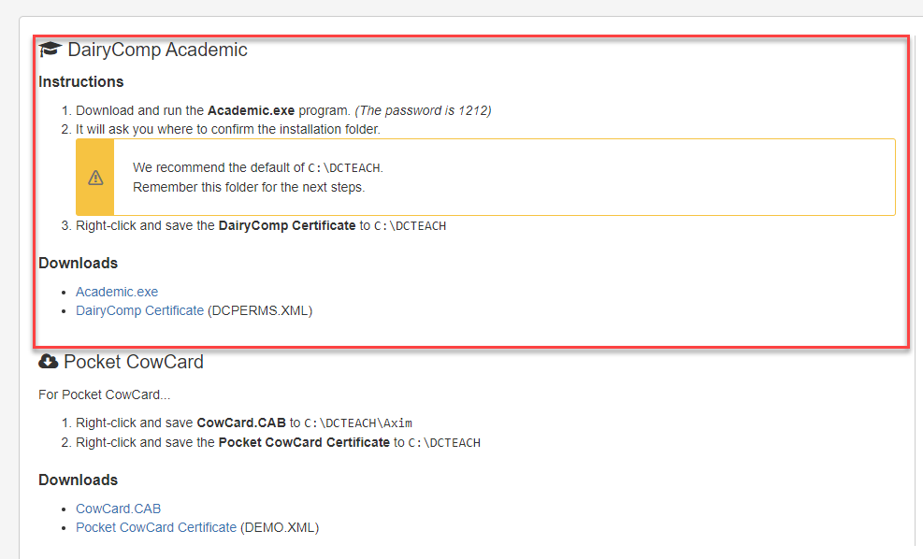
- Double left click the Dairy Comp Academic icon 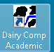 to start the program. And logon to the DC-Teach Demo Herd to verify the installation.

