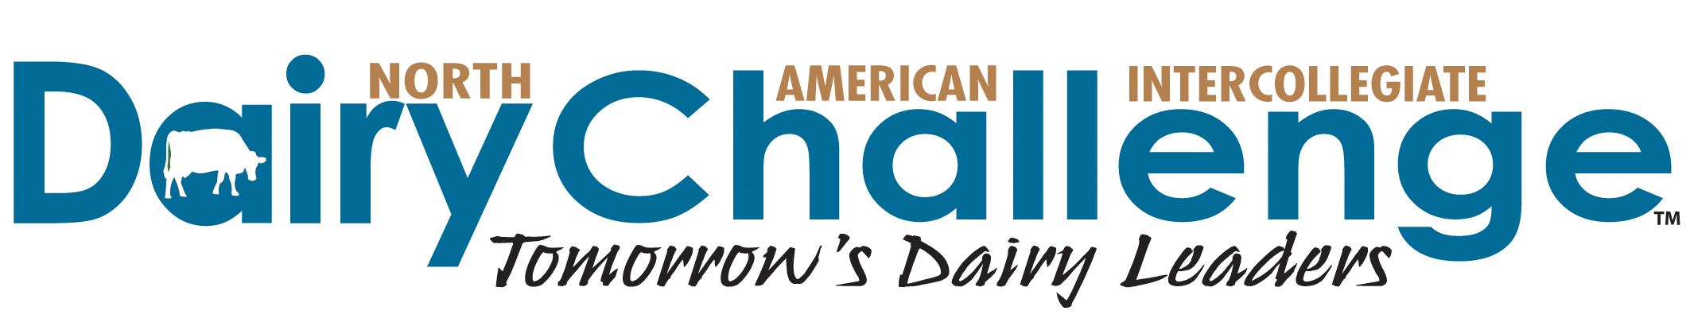
November 26, 2018

The 14th Annual Western Regional Dairy Challenge will be held in Ogden, Utah, February 21-23, 2019. Registration Entry and Student Information forms are available to complete online at the National Dairy Challenge website www.dairychallenge.org under the Western tab.

New this year, registration fee is $25 per student participant and is due at time of entry. On average, it costs the Western Region approximately $350 per student attending the western contest. Our ability to cover these costs depends greatly on support of our dairy industry, which has experienced difficult times. While the decision is up to the schools to pay this fee or request it of the student, the regional committee felt students who have paid even a small amount have demonstrated ownership in their participation and the program.

Deadline to register is Friday, December 14, 2018. Each school may register up to 5 students and 5 alternates. Schools will be notified of their acceptance shortly after the December 14 deadline. Please review Contest Rules, Eligibility of Contestants as you select participating students.

To register: go to https://2019westerndairychallenge.eventbrite.com Be prepared with your students’ email addresses when you begin registration.

Coaches do not have to collect and submit student forms. Once participation is confirmed (on or about December 19), students will be responsible for completing a Student Information form online. A link to this form will be available on the Dairy Challenge web site after confirmations are sent, on or around December 19. Students have until February 1, 2019 to submit their form. Failure to submit the form by the deadline will result in the student being dropped from the contest. The signing of the Contestant Liability Waiver, Contest Information Release Waiver, and the Contestant Honor Code will be handled on site at the event.

We are in the process of confirming location, so more information will forthcoming.

The Challenge will cover up to $1,200 in travel costs. Hotel rooms and meals at the contest are provided.
Contest management will make all the necessary hotel reservations for your team and yourself. This will consist of a room for students on Thursday and Friday, which will be covered by sponsorships. If any coaches would like to share rooms, please inform the planning committee.

Please note that rooms will be reserved using the student names provided on your registration form. Due to deadlines imposed by the hotel for rooming lists and to ensure the contest flows smoothly, we ask you make final any and all changes to students participating by February 1. Should you not need all the rooms that have been reserved, it is your responsibility to notify the management staff at least 3 days prior to the contest in order to have the rooms cancelled. In the event that you fail to notify us, you will be responsible for reimbursement of the unused rooms. If your team is unable to return to your home campus for Saturday night, this night will also be covered at a hotel of your choice, with the cost per room not to exceed the cost of the room in Ogden.

The official schedule of events for the three days of the contest will be provided in late January. Contest rules are available at the NAIDC website and your students should be aware of the rules and scorecard. A small number of laptop computers are being graciously provided by the University of Idaho. Each university should still bring at least 1 university laptop computer, 2 if possible.

Communications will follow once registration closes in mid December with additional information, and in mid February with last minute details. As we continue to develop this contest for the future, we appreciate your input to improve the educational experience for your students. The Western Regional Dairy Challenge Committee looks forward to meeting you and your team at the 2019 Contest!

Sincerely,

Western Regional Dairy Challenge Committee

