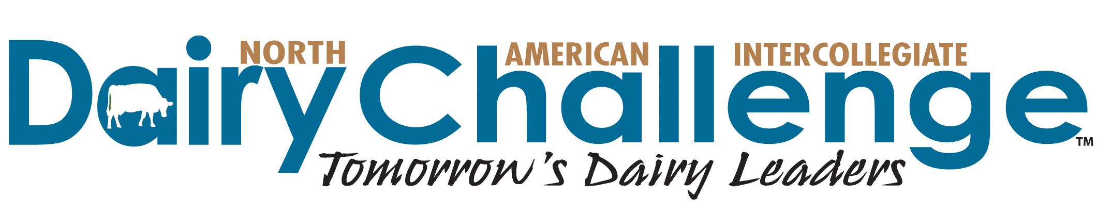

FOR IMMEDIATE RELEASE

Contact: Renee Smith, Virtus Nutrition
661-699-8552 or rsmith@omegabalancer.com

52 collegiate students participate in 14th annual Western Regional Dairy Challenge

Fifty-two students from six Western U.S. universities and one Canadian college traveled to Ogden, Utah, for the 14th annual Western Dairy Challenge on February 21 – 23, 2019. The contest was hosted by Utah State University.

The Western Regional Dairy Challenge is a three-day educational competition designed to prepare students for dairy careers. Working in mixed-university teams of four or five students, participants assessed all aspects of a working dairy farm, including facilities, nutrition, financials, reproduction and animal health. Students collaborated on a 20-minute team presentation that detailed their observations and suggestions to a panel of judges. Teams were ranked based on how well their evaluations matched the judges’ evaluations of the dairy operation.

On Thursday students sharpened their farm financial skills with a workshop taught by Tony Powell, from Western Ag Credit. Next, students participated in a team building event, where they learned about behaviors of successful teamwork with a focus on listening and respect. As part of the team building exercise, they sampled local, artisan cheese from Beehive Cheese and worked together to come up with creative descriptions of the cheeses that could be used on a menu. They also kicked off the competition portion of the event where they assembled into aggregate teams (meeting their new teammates from other universities for the first time) and spent the evening diving into the host dairy’s records to assess the strengths and weaknesses that show up in the numbers.

On Friday morning, the teams headed out to the local host dairy that graciously opened their doors to the students. They spent 3 1/2 hours walking the facility, observing the cows and the management aspects of the operation. Following the on-farm assessment, the students participated in a question and answer session with the management team of the dairy. Several sponsors attending the event networked with and mentored the students throughout the weekend.

On Saturday morning, students presented their findings to a panel of judges made up of a nutritionist, a veterinarian, a financial analyst and a dairy producer who ranked them on their presentation and conclusions. Students also had the opportunity to hear the judging panel’s full critique of the dairy’s opportunities to round out this learning experience.

1st Place Teams:

Team 3 - Brian Head
(L-R) Back Row: Melissa Pochapsky (University of Alberta), Lars Schilderink (Cal Poly State University - SLO), Haley Hill (Texas A&M University) Front Row: Osvaldo Gonzalez (Utah State University), Whitney Sandberg (University of Idaho)

Team 10 - Snowbasin
(L-R) Jerod Berrett (Utah State University), Ashly Anderson (University of Idaho), Natalie Koke (Texas A&M University), Alexandra Gambonini (Cal Poly State University - SLO)

Team 11 - Solitude
(L-R) Back Row: Jessica Muxlow (University of Alberta), Caleb Zwart (California State University – Fresno) Front Row: Kailey Foster (Utah State University), Elisabeth Regusci (Cal Poly State University - SLO)

2nd Place Teams:

Team 1 - Alta
(L-R) Back Row: Mackenzie Smithyman (Washington State University), Trevor Maciel (Cal Poly State University), Kendra DeCory (University of Idaho) Front Row: Hannah Neer (Cal Poly State University - SLO), Austin Hansen (University of Idaho)

Team 8 - Park City
(L-R) Back Row: Mark Hooker (California State University – Fresno), Marta Pulfer (Texas A&M University) Front Row: Maddsion Degenshein (University of Idaho), Mackenzie Peters (Cal Poly State University - SLO)

Team 12 - Sundance
(L-R) Back Row: William Wolf (Texas A&M University), Hank DeVries (Cal Poly State University – SLO) Front Row: Juanita Echeverry-Munera (University of Alberta), Summer Call (Cal Poly State University – SLO), Morgan Hawley (Washington State University)

A committee of dairy industry representatives organized the Dairy Challenge, led by local host volunteers, Dr. Allen Young from Utah State University and Dallin Buttars, a Dairy Challenge Alumni, from Select Sires. In addition, a long list of volunteers was important to the competition’s success, as is the case for every Dairy Challenge event. To volunteer or become a sponsor for the 2020 contest, contact Molly Kelley at mollyk@dairychallenge.org or Renee Smith at rsmith@omegabalancer.com, or go to dairychallenge.org for more information. All contributions are tax deductible and contributing sponsor listings are available on the website.

The Western Regional Dairy Challenge is under the guidance and support of the North American Intercollegiate Dairy Challenge (NAIDC), which was established in April 2002 as a collegiate management contest to incorporate evaluation of all aspects of a specific dairy business. For more information, visit www.dairychallenge.org. The four regional events lead to the national contest of a similar format, which will be held on March 28-30, 2019, in Tifton, Georgia.

###

Google Photos Link:

Captions in the Info Section of each photo

https://photos.app.goo.gl/hEXE7rnYpG38SX7EA

