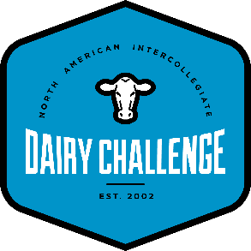
NEWS RELEASE
Dairy Challenge Vet
April 5, 2019

The Ohio State University Food Animal Medicine Club hosted its annual Food Animal Medicine Student Symposium (FAMSS) over the weekend of April 5-7, 2019 where veterinary students from all North American veterinary colleges are invited to participate in wet labs and lectures to enhance their food animal veterinary medical education. In conjunction with the symposium, Dairy Challenge Vet, sponsored by Merck Animal Health, was hosted by Ohio State, the third annual dairy challenge competition associated with FAMSS and first year partnered with the North American Intercollegiate Dairy Challenge organization.

A total of nine teams from Kansas State University, University of Wisconsin - Madison, University of Minnesota, North Carolina State University, University of Calgary, and The Ohio State University competed in the competition on Friday, April 5, 2019. This was the largest FAMSS-associated dairy challenge event hosted yet! Teams spent two hours evaluating Ack-Lee Registered Holsteins, owned and operated by Jay and Kristy Ackley, where they made detailed observations in regards to the animals, facilities, and DHI records. Later in the day, teams assessed their findings as a group and collaborated to deliver a professional summary of the farm’s strengths and opportunities in front of a panel of judges. This year’s judges who graciously donated their time and expert insights about the farm were: Dr. Tony Good, DVM (Select Sires, Inc), Dr. Em Mowrer, DVM (Stonehouse Veterinary Service), Ryan Aberle (Cargill Animal Nutrition), and Dr. Paige Gott, PhD (BIOMIN America, Inc).

University of Wisconsin - Madison took first place, followed by North Carolina State University, and University of Minnesota was given honorable mention.

The purpose of the dairy challenge event is to familiarize students with identifying and improving common issues that veterinarians face every day on dairy farms. According to feedback received by student participants and judges, Dairy Challenge Vet has certainly fulfilled its purpose and aims to continue having an impact on students. On behalf of the Food Animal Club at The Ohio State University College of Veterinary Medicine, we would like extend our appreciation to Merck Animal Health for their immense support in helping to pilot not only the first contest in 2017, but also the second and third annual events in 2018 and 2019. Merck’s tremendous support has allowed dozens of veterinary students interested in bovine medicine to strengthen their knowledge outside of the classroom by participating in hands-on analysis of real-life veterinary situations on modern dairy operations. We also graciously thank the North American Intercollegiate Dairy Challenge organization for adopting the event and providing great support and resources that will help ensure the existence of this event into the future and continue providing an invaluable opportunity for veterinary students around the country.

Marina Sweet
The Ohio State University
College of Veterinary Medicine
DVM Candidate, Class of 2022
B.S. in Agriculture | Animal Science

