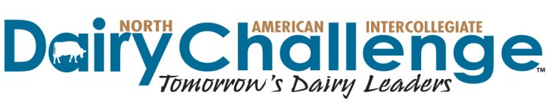
12th Annual Southern Regional Dairy Challenge
November 12-14, 2017 — Live Oak, Florida
Hosted by University of Florida

UPDATED HOTEL INFORMATION: ACV has informed us that internet will be fully functional for guests in the Village Lodge rooms. If you prefer to stay on site, there are still rooms available at the ACV Village Lodge at a nightly rate of $74.95. To reserve a room, call PH: 800-371-8381
On behalf of the Southern Regional Committee of the North American Intercollegiate Dairy Challenge, it is our privilege to invite you to participate in the 12th Annual Southern Regional Dairy Challenge. The event will be held at Advent Christian Village (AVC) Conference & Retreat Center in Live Oak, Florida November 12-14 and hosted by University of Florida.
SPONSOR PARTICIPATION: We are building our list of volunteers to help with the event Sunday evening through Tuesday afternoon. Being involved and working directly with the students gives you a first‐hand view of the students in action, plus a large volunteer pool helps the contest run smoothly.
SCHEDULE: A listing of the scheduled events for this year's contest is posted on the Southern Dairy Challenge web page at http://www.dairychallenge.org/so_event.php
SPONSOR VOLUNTEER REGISTRATION: Please submit information for each volunteer from your company using the online Sponsor Volunteer Registration form posted at http://www.dairychallenge.org/so_event.php Forms are due Wednesday, November 1, 2017.
HOTEL: This year's event is being held at the ACV Conference & Retreat Center in Live Oak, Florida. For your convenience, a block of rooms at the ACV Village Lodge is held under Southern Regional Dairy Challenge at a nightly rate of $74.95. Please call the lodge to request a room at this rate in our block. There is also Holiday Inn Express in the town of Live Oak, approximately 20 miles from the retreat center.
Village Lodge at ACV Conference & Retreat Center
11057 Dowling Park Drive
Live Oak, Florida 32060
PH: 800-371-8381

Holiday Inn Express
6694 US 129 North
Live Oak, Florida 32060
PH: 386-362-2600
MEALS: Meal tickets will be provided to sponsor volunteers based on sponsorship: Platinum sponsor companies receive 4 meal tickets for the duration of the contest, Gold sponsor companies receive 3, Silver receive 2 and Bronze receive 1. If you have additional meal ticket needs, you can purchase them separately by calling NAIDC at 608-224-0400. We appreciate your help with this!
SPONSOR DISPLAYS: On Tuesday morning, you are invited to set up a table top display in our Career & Innovation Fair. Displays will be open between 8:00 AM and 2:15 PM. Indicate your desire to reserve a table using the online registration form. There is no charge for tables. You will be provided with a six-foot table (if needed). Electricity will be available, but you will need to supply your own electrical cords. All sponsors are encouraged to interact with students and university coaches, and view student presentations on Tuesday. But remember because of the number of teams, presentations will be going on simultaneously.
If you have questions about volunteering your company's time at the event, please communicate with volunteer coordinator Stephanie Ward, (919) 602-1100, shward@ncsu.edu

